Supplementary Information

- Supplemental Methods and Materials

- Supplemental Tables

Table S1 General information about six FACE experimental sites in this study
Table S2 Summary of samples used in this study
Table S3 Summary of plots and plot coordinates for all samples for this study.
Table S4 Effects of site, CO₂ and their interaction on soil properties
Table S5 The distance decay relationship at the functional gene and category levels

- Supplemental Figures
Figure S1 Location of six FACE experimental sites in this study
Figure S2 The distance-decay rates within individual sites at aCO₂ and eCO₂

- Supplemental references

- Supplemental Materials and Methods
Description, background and sampling of six sites/ecosystems
BioCON. The BioCON (Biodiversity, CO₂, Nitrogen deposition) experiment site is a planted native grassland containing a total of 296 plots with three treatments: CO₂ (ambient, 368 ppm vs elevated, 560 ppm), N (ambient vs. 4 g NH₄NO₃ m⁻² year⁻¹), and plant diversity (1, 4, 9 or 16 native grass species in four functional groups: C₃, C₄, forb and legume) . Previous studies showed increased soil pH, soil moisture, and bacterial biomass, and shifts of both phylogenetic and functional composition, structure and interaction network of soil microbial communities under eCO₂ . In this study, we analyzed soil microbial communities sampled from 24 plots (12 for aCO₂ and 12 for eCO₂) with 16 species and without N addition in July 2007 when this site was exposed to eCO₂ for 10 years.
Duke. The Duke Forest FACE experiment is a pine-dominated (>90% of basal area) forest ecosystem. Elevated CO₂ concentration is maintained 200 ppm (e.g., 585 ppm) above the ambient level (e.g., 385 ppm). Soils are highly weathered clay loams (mixed thermic Ultic Hapludalfs), and a detailed description of the site can be found in Lichter et al.. Soil moisture tended to increase at eCO₂ although soil pH varied relatively little (4.1 to 5.2) between aCO₂ and eCO₂ samples . Previous studies showed that limited available N in soil constrained C sequestration at eCO₂, while eCO₂ increased the release of soluble C from roots to soil, thus accelerating turnover of N pools in the rhizosphere . Another study showed that the acid to aldehyde ratios of lignin-derived phenols increased and leaf-derived alkyl structures were enriched under eCO₂ and N fertilization, suggesting an enhanced degradation of lignin and hydrolysable lipid components. In this study, we analyzed soil microbial communities from 16 plots (8 each for aCO₂ and eCO₂) sampled in July 2008 when this site was exposed to eCO₂ for 15 years.
ORNL. The Oak Ridge National Laboratory (ORNL) FACE experiment is a sweetgum (Liquidambar styraciflua L.) plantation with four 25-m diameter plots with two eCO₂ (~ 544 ppm) and two aCO₂ (~ 376 ppm) . The soil is classified as Aquic Haplidult with a pH of approximately 5.5-6.0, and a previous studies indicate no significant changes with the soil microbial community, soil pH, or soil moisture at eCO₂, while soil N availability declined significantly faster at eCO₂ , arising a question if the CO₂ fertilization effect is sustainable, especially in N limited forest ecosystems at eCO₂ conditions . One possibility is that eCO₂-grwon trees may be able to access a larger inorganic N pool in deeper soil by increased root exploration at eCO₂ . In this study, 12 samples (6 each for aCO₂ and eCO₂) sampled in July 2008 were analyzed when this site was exposed to eCO₂ for 10 years.
SoyFACE/MaizeFACE. The SoyFACE is a typical corn-soybean rotation agroecosystem with a randomized complete block design (n = 4) with each block containing four treatments: (i) ambient CO₂ (~400 ppm in 2008) and O₃ (~37.9 ppb in 2008), (ii) elevated CO₂ (~550 ppm), (iii) elevated O₃ (~ 61.3 ppb in 2008), and (iv) a combination of elevated CO₂ and O₃. The soil is Drummer–Flanagan (fine-silty, mixed, mesic Typic Endoaquoll) with a pH of 5.73–6.14, which was not significantly affected by eCO₂ , but eCO₂ did generally increase soil moisture for both SoyFACE and MaizeFACE experiments . It is hypothesized that legumes like soybean have a competitive advantage over non-legumious species at eCO₂ , while C₄ plants (e.g., corn) may not be as sensitive as C₃ grasses or other plants in response to eCO₂ . In this study, 24 soil samples were collected for CO₂ treatments (ambient and elevated CO₂) in October 2008 from SoyFACE plots and 24 soil samples in May 2009 from MaizeFACE plots at the depth of 0-15 cm. This site was exposed to eCO₂ for 7 or 8 years, respectively.
PHACE. The PHACE (Prairie Heating and Carbon Dioxide Enrichment) experiment includes a factorial combination of two levels of CO₂ (ambient 400 ppm vs elevated 600 ppm) and two temperature (ambient vs elevated with 1.5/3.0ºC warmer day/night) regimes with five replications for each treatment randomly assigned 20 (3.3-m diameter) circular plots. The soil is a fine-loamy, mixed, mesic Aridic Argiustoll with pH of 7.9, which was not significantly affected by eCO_{2,} while soil moisture significantly increased at eCO₂ . It is a mixed-grass prairie semiarid ecosystem dominated by C₄ grasses, C₃ grasses, and forbs and sub-shrubs, and details of the experimental site, design and setup are as previously described. A previous study showed that microbially mediated CH₄ consumption was significantly higher but N₂O emission was not significantly affected under elevated CO₂ , and another study indicated that eCO₂ completely reversed the desiccation effects of moderate warming, and favored C₃ grasses and enhanced stand productivity, whereas warming favored C₄ grasses . A recent laboratory incubation study from PHACE showed that eCO₂ microbial communities had an increased ability to decompose soil organic matter (SOM) compared with those from ambient CO₂ plots, suggesting positive feedbacks of soil microbial communities to this semi-arid ecosystem . In this study, we only analyzed soil microbial communities from 10 plots (5 for aCO₂ and 5 for eCO₂) sampled in July 2008 when this site was exposed to eCO₂ for only 2 years.
Analysis of soil properties
Soil NO₃-N and NH₄-N were extracted with 1 M KCl solution and quantified by a Flow Injection Autoanalyzer . Soil organic carbon and total N were determined using a LECO Truspec dry combustion carbon analyzer .
DNA extraction, purification and quantitation
Soil DNA was extracted by freeze-grinding mechanical lysis as described previously, and was purified using a low melting agarose gel followed by phenol extraction. DNA quality was assessed by the ratios of 260 nm/280 nm, and 260/230 nm using a NanoDrop ND-1000 Spectrophotometer (NanoDrop Technologies Inc., Wilmington, DE), and final DNA concentrations were quantified with PicoGreen using a FLUOstar Optima (BMG Labtech, Jena, Germany).
GeoChip analysis
GeoChip 3.0 was used to analyze all 110 soil DNA samples, and it contains about 28,000 probes covering approximately 57,000 gene variants from 292 functional gene families involved in C, N, P and S cycling, energy metabolism, antibiotic resistance, metal resistance and organic contaminant degradation , and GeoChip-based hybridization detection is considered quantitative . Details for target preparation, labeling, and GeoChip hybridization as well as data analysis are previously described . Briefly, 50 ng of DNA was used as template for the whole community genome amplification (WCGA) , and 3.0 µg of amplified DNA was labeled and then hybridized with GeoChip 3.0 at 45ºC with 50% formamide. The image was processed and spots with a signal to noise ratio (SNR) > 2.0 were considered as positive signals , and raw data were pre-processed.
Statistical analysis
Multivariate and direct gradient analysis. Permutational multivariate analysis of variance (PERMANOVA) was used to evaluate the contribution of site/ecosystem and CO₂ as well as their interaction to microbial community variations with the Adonis function, and to partition sums of squares from a centroid based on a Bray-Curtis dissimilarity matrix implemented in R . It first calculates the distances among samples and then permutates the distance matrix for 999 times. Since our experiments were carried out in six experimental sites, randomization was only implemented within each site to control the effect across all sites. Significance tests were done using F-test based on sequential sums of squares from permutations. Different datasets of microbial communities generated with different analytical methods were used to examine whether different locations and/or elevated atmospheric CO₂ has significant effects on soil microbial communities. All three procedures (anosim, adonis and mrpp) were performed with the Vegan package in R.
Calculations of geographic distances and β-diversity
To create a geographic distance matrix between any two sampling sites, the geographic distance was calculated using latitudinal and longitudinal coordinates (Table S5) and the Haversine formula. β-diversity of soil microbial communities was analyzed using the Sørensen method. The distance-decay relationship was plotted as logarithmic similarity against logarithmic distance. A linear regression was used to obtain the slope. To examine the significance of distance-decay relationships, we tested if those slopes were significantly less than zero . Also, the significance of slopes between aCO₂ and eCO₂ was tested by permutation. It was considered as significant if p value < 0.05 in this study.
Multiple regression on matrices (MRM)
To identify the relative importance of multiple factors contributing to the distance-decay relationship, a multiple regression on matrices (MRM) was used . The partial regression coefficients of an MRM model give a measure of the rate of change in the soil microbial community similarity for variables of interests when other variables were held constant .

B. Supplemental Tables

Table S1 Summary information about six FACE experimental sites/ecosystems in this study.

Project | BioCONª | Duke^{b} | ORNL^{c} | MaizeFACE^{d} | SoyFACE^{d} | PHACE^{e}
Site | Cedar Creek Ecosystem Science Reserve, MN | Duke Forest, NC | Oak Ridge, TN | Urbana-Champaign, IL |  | Cheyenne, WY
Ecosystem | Native C₃ grass, C₄ grass, legume, and forb species | Loblolly pine forest | Sweetgum plantation | Corn/Soybean rotation |  | Mixed grass prairie
Elevated CO₂ | 560 ppm | Ambient + 200 ppm | 550 ppm | 550 ppm |  | 600 ppm
Other treatment | Plant diversity, and nitrogen | Soil nutrients | None | O₃, temperature, and drought |  | Temperature
Lat/Lon | 45°24' N/  93°12' W | 35°58' N/  79°5' W | 35°54' N/  84°20' W | 40°2' N/88°13' W |  | 41°11’N  104°54’W
Start-end year | 1997- | 1994-2010 | 1998 - 2009 | 2001- |  | 2006-2013

a. BioCON (Biodiversity, CO₂ and Nitrogen): http://www.biocon.umn.edu/
b. Duke Forest-Atmosphere Carbon Transfer and Storage (FACTS-I): http://face.env.duke.edu/main.cfm/
c. ORNL FACE: http://face.ornl.gov/
d. MaizeFACE and SoyFACE: http://soyface.illinois.edu/index.htm/
e. PHACE (Prairie Heating and CO₂ Enrichment): http://www.ars.usda.gov/Research/docs.htm?docid=16754/

Table S2 Summary of samples used in this study (ambient CO₂ vs elevated CO₂). A total of 110 (55 for each CO₂ condition) were analyzed.

Site | BioCON | Duke | ORNL | MaizeFACE | SoyFACE | PHACE
Ecosystem | Grassland | Forest | Forest | Soybean | Corn | Grassland
Ring/block | 6 |  | 4/5 | 8 | 8 | 2
Plot | 24 | 16 | 12/15 | 24 | 24 | 10
Replicates | 12 | 8 | 6 | 12 | 12 | 5
Depth | 0-15 cm | 0-10 cm | 0-15 | 0-15 cm | 0-15 cm | 0-15 cm
Sub-total | 24 | 16 | 12 | 24 | 24 | 10
Sampling time | July 2007 | July 2008 | July 2008 | October 2008 | May 2009 | July 2008
eCO₂ exposure | 10 years | 15 years | 10 years | 7 years | 7.5 years | 2 years

Table S3 Summary of plots and plot coordinates for all samples for this study.

Site | CO₂ | Plot | Latitude | Longitude
BioCON | Ambient | 67 | -93.19 | 45.40
BioCON | Ambient | 69 | -93.19 | 45.40
BioCON | Ambient | 104 | -93.19 | 45.40
BioCON | Ambient | 107 | -93.19 | 45.40
BioCON | Ambient | 184 | -93.19 | 45.40
BioCON | Ambient | 188 | -93.19 | 45.40
BioCON | Ambient | 201 | -93.19 | 45.40
BioCON | Ambient | 222 | -93.19 | 45.40
BioCON | Ambient | 306 | -93.18 | 45.40
BioCON | Ambient | 344 | -93.18 | 45.40
BioCON | Ambient | 355 | -93.18 | 45.40
BioCON | Ambient | 358 | -93.18 | 45.40
Duke | Ambient | 1A | -79.09 | 35.98
Duke | Ambient | 5A | -79.09 | 35.98
Duke | Ambient | 6A | -79.09 | 35.98
Duke | Ambient | 8A | -79.09 | 35.97
Duke | Ambient | 9A | -79.09 | 35.98
Duke | Ambient | 10A | -79.09 | 35.98
Duke | Ambient | 11A | -79.09 | 35.98
Duke | Ambient | 12A | -79.09 | 35.97
ORNL | Ambient | S4a | -84.34 | 35.90
ORNL | Ambient | S4b | -84.34 | 35.90
ORNL | Ambient | S4c | -84.34 | 35.90
ORNL | Ambient | S5a | -84.34 | 35.90
ORNL | Ambient | S5b | -84.34 | 35.90
ORNL | Ambient | S5c | -84.34 | 35.90
MaizeFACE | Ambient | 1S1 | -88.24 | 40.04
MaizeFACE | Ambient | 1S2 | -88.24 | 40.04
MaizeFACE | Ambient | 1S3 | -88.24 | 40.04
MaizeFACE | Ambient | 4S1 | -88.24 | 40.04
MaizeFACE | Ambient | 4S2 | -88.24 | 40.04
MaizeFACE | Ambient | 4S3 | -88.24 | 40.04
MaizeFACE | Ambient | 10S1 | -88.23 | 40.04
MaizeFACE | Ambient | 10S2 | -88.23 | 40.04
MaizeFACE | Ambient | 10S3 | -88.23 | 40.04
MaizeFACE | Ambient | 11S1 | -88.23 | 40.04
MaizeFACE | Ambient | 11S2 | -88.23 | 40.04
MaizeFACE | Ambient | 11S3 | -88.23 | 40.04
SoyFACE | Ambient | 17S1 | -88.23 | 40.04
SoyFACE | Ambient | 17S2 | -88.23 | 40.04
SoyFACE | Ambient | 17S3 | -88.23 | 40.04
SoyFACE | Ambient | 24S1 | -88.23 | 40.04
SoyFACE | Ambient | 24S2 | -88.23 | 40.04
SoyFACE | Ambient | 24S3 | -88.23 | 40.04
SoyFACE | Ambient | 25S1 | -88.23 | 40.04
SoyFACE | Ambient | 25S2 | -88.23 | 40.04
SoyFACE | Ambient | 25S3 | -88.23 | 40.04
SoyFACE | Ambient | 32S1 | -88.23 | 40.04
SoyFACE | Ambient | 32S2 | -88.23 | 40.04
SoyFACE | Ambient | 32S3 | -88.23 | 40.04
PHACE | Ambient | 8 | -104.89 | 41.20
PHACE | Ambient | 12 | -104.89 | 41.20
PHACE | Ambient | 14 | -104.89 | 41.20
PHACE | Ambient | 22 | -104.89 | 41.20
PHACE | Ambient | 25 | -104.89 | 41.20
BioCON | Elevated | 23 | -93.19 | 45.41
BioCON | Elevated | 33 | -93.19 | 45.41
BioCON | Elevated | 45 | -93.19 | 45.41
BioCON | Elevated | 51 | -93.19 | 45.41
BioCON | Elevated | 147 | -93.19 | 45.40
BioCON | Elevated | 163 | -93.19 | 45.40
BioCON | Elevated | 173 | -93.19 | 45.40
BioCON | Elevated | 179 | -93.19 | 45.40
BioCON | Elevated | 250 | -93.18 | 45.40
BioCON | Elevated | 270 | -93.18 | 45.40
BioCON | Elevated | 272 | -93.18 | 45.40
BioCON | Elevated | 283 | -93.18 | 45.40
Duke | Elevated | 2A | -79.09 | 35.98
Duke | Elevated | 3A | -79.09 | 35.98
Duke | Elevated | 4A | -79.09 | 35.98
Duke | Elevated | 7A | -79.09 | 35.97
Duke | Elevated | 2B | -79.09 | 35.98
Duke | Elevated | 3B | -79.09 | 35.98
Duke | Elevated | 4B | -79.09 | 35.98
Duke | Elevated | 7B | -79.09 | 35.97
ORNL | Elevated | S1a | -84.34 | 35.90
ORNL | Elevated | S1b | -84.34 | 35.90
ORNL | Elevated | S1c | -84.34 | 35.90
ORNL | Elevated | S2a | -84.34 | 35.90
ORNL | Elevated | S2b | -84.34 | 35.90
ORNL | Elevated | S2c | -84.34 | 35.90
MaizeFACE | Elevated | 3S1 | -88.24 | 40.04
MaizeFACE | Elevated | 3S2 | -88.24 | 40.04
MaizeFACE | Elevated | 3S3 | -88.24 | 40.04
MaizeFACE | Elevated | 5S1 | -88.23 | 40.04
MaizeFACE | Elevated | 5S2 | -88.23 | 40.04
MaizeFACE | Elevated | 5S3 | -88.23 | 40.04
MaizeFACE | Elevated | 14S1 | -88.23 | 40.04
MaizeFACE | Elevated | 14S2 | -88.23 | 40.04
MaizeFACE | Elevated | 14S3 | -88.23 | 40.04
MaizeFACE | Elevated | 15S1 | -88.23 | 40.04
MaizeFACE | Elevated | 15S2 | -88.23 | 40.04
MaizeFACE | Elevated | 15S3 | -88.23 | 40.04
SoyFACE | Elevated | 20S1 | -88.23 | 40.04
SoyFACE | Elevated | 20S2 | -88.23 | 40.04
SoyFACE | Elevated | 20S3 | -88.23 | 40.04
SoyFACE | Elevated | 21S1 | -88.23 | 40.04
SoyFACE | Elevated | 21S2 | -88.23 | 40.04
SoyFACE | Elevated | 21S3 | -88.23 | 40.04
SoyFACE | Elevated | 28S1 | -88.23 | 40.04
SoyFACE | Elevated | 28S2 | -88.23 | 40.04
SoyFACE | Elevated | 28S3 | -88.23 | 40.04
SoyFACE | Elevated | 29S1 | -88.23 | 40.04
SoyFACE | Elevated | 29S2 | -88.23 | 40.04
SoyFACE | Elevated | 29S3 | -88.23 | 40.04
PHACE | Elevated | 3 | -104.89 | 41.20
PHACE | Elevated | 7 | -104.89 | 41.20
PHACE | Elevated | 11 | -104.89 | 41.20
PHACE | Elevated | 26 | -104.89 | 41.20
PHACE | Elevated | 27 | -104.89 | 41.20

Table S4 The effect of site and CO₂ on soil properties analyzed by ANOVA.

 | Site |  | CO₂ |  | Site x CO₂
 | F value | P > F | F value | P > F | F value | P > F
Nitrate | 52.253 | <0.0001 | 2.9209 | 0.0906 | 6.435 | <0.0001
Ammonium | 14.0834 | <0.0001 | 1.2869 | 0.2594 | 0.828 | 0.5328
Total nitrogen (TN) | 16.3036 | <0.0001 | 0.7447 | 0.3903 | 0.7665 | 0.5761
Total carbon (TC) | 9.2797 | <0.0001 | 0.8297 | 0.3646 | 0.3235 | 0.8978
C:N ratio | 22.1813 | <0.0001 | 1.0774 | 0.3018 | 0.3785 | 0.8624

Table S5 The significant distance decay relationships of key functional genes/categories at aCO₂ and eCO₂ and their significance of slopes (p values) between aCO₂ and eCO₂ by permutation tests.

Functional category and gene/enzyme | aCO₂ |  | eCO₂ |  | Significance (aCO₂ vs. eCO₂)
Functional category and gene/enzyme | r | Slope | r | Slope | Significance (aCO₂ vs. eCO₂)
Carbon cycling | -0.292 | -0.035 | -0.321 | -0.034 | 0.104
amyA | -0.190 | -0.013 | -0.293 | -0.016 | <0.001
Endochitinase | -0.168 | -0.010 | -0.268 | -0.014 | <0.001
Phenol oxidase | -0.159 | -0.010 | -0.212 | -0.014 | <0.001
Acc/Pcc | -0.154 | -0.009 | -0.232 | -0.014 | <0.001
Rubisco | -0.135 | -0.010 | -0.254 | -0.014 | <0.001
CODH | -0.112 | -0.008 | -0.269 | -0.016 | <0.001
Nitrogen cycling | -0.263 | -0.027 | -0.307 | -0.027 | 0.036
nifH | -0.181 | -0.010 | -0.269 | -0.013 | <0.001
narG | -0.180 | -0.010 | -0.251 | -0.012 | <0.001
nirK | -0.185 | -0.011 | -0.272 | -0.014 | <0.001
nirS | -0.142 | -0.009 | -0.255 | -0.013 | <0.001
nosZ | -0.145 | -0.008 | -0.259 | -0.014 | <0.001
ureC | -0.076 | -0.006 | -0.243 | -0.012 | <0.001
Sulfur cycling | -0.298 | -0.028 | -0.338 | -0.028 | 0.747
dsrA | -0.133 | -0.008 | -0.244 | -0.012 | <0.001
dsrB | -0.156 | -0.011 | -0.259 | -0.015 | <0.001
Phosphorus cycling | -0.233 | -0.023 | -0.288 | -0.026 | <0.001
ppx | -0.145 | -0.008 | -0.245 | -0.012 | <0.001
Energy process | -0.252 | -0.020 | -0.293 | -0.019 | <0.001
Cytochrome | -0.124 | -0.008 | -0.226 | -0.012 | <0.001
Phylogeny (gyrB) | -0.155 | -0.009 | -0.253 | -0.013 | <0.001
Organic Remediation | -0.202 | -0.017 | -0.307 | -0.020 | <0.001
alkK | -0.174 | -0.014 | -0.292 | -0.019 | <0.001
linB | -0.137 | -0.011 | -0.263 | -0.017 | <0.001
mdlA | -0.207 | -0.015 | -0.267 | -0.015 | 0.457
nmoA | -0.223 | -0.018 | -0.273 | -0.018 | 0.890
pcaG | -0.124 | -0.008 | -0.284 | -0.016 | <0.001
phn | -0.139 | -0.008 | -0.262 | -0.011 | <0.001
pimF | -0.187 | -0.012 | -0.286 | -0.015 | <0.001
tfdA | -0.234 | -0.018 | -0.303 | -0.019 | 0.068
Metal Resistance | -0.247 | -0.020 | -0.320 | -0.021 | <0.001
arsC | -0.150 | -0.010 | -0.267 | -0.016 | <0.001
chrA | -0.132 | -0.008 | -0.268 | -0.013 | <0.001
copA | -0.190 | -0.012 | -0.259 | -0.014 | <0.001
czcA | -0.150 | -0.011 | -0.226 | -0.012 | <0.001
czcD | -0.182 | -0.012 | -0.271 | -0.014 | <0.001
terC | -0.161 | -0.009 | -0.272 | -0.014 | <0.001
zntA | -0.166 | -0.011 | -0.263 | -0.014 | <0.001

- Supplemental Figures

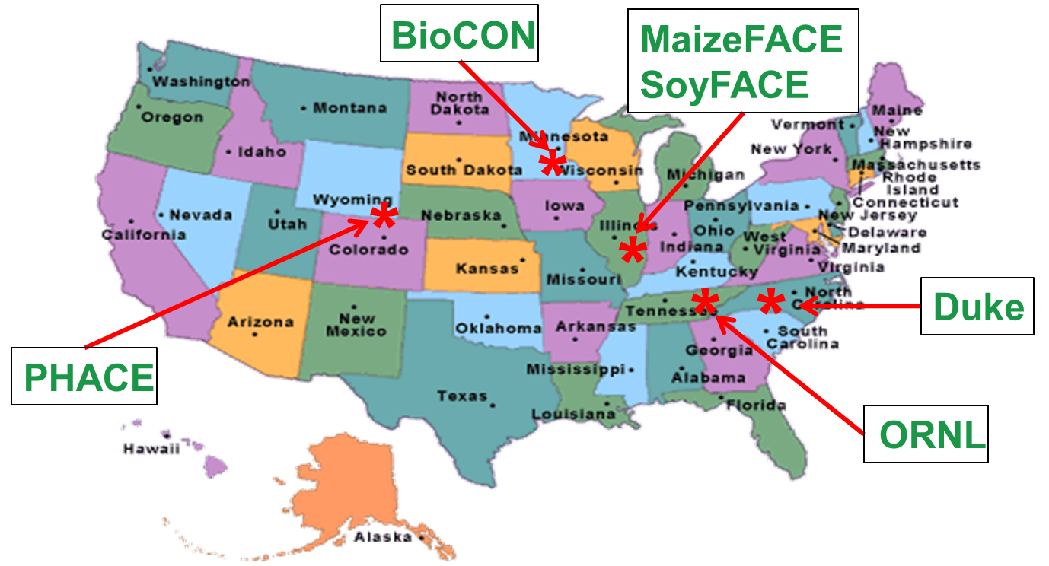

Figure S1 Location of six FACE experimental sites in this study. They are BioCON, Duke, ORNL, MaizeFACE, SoyFACE, and PHACE. Details about those sites are described in the Supplementary Information A (Supplemental Materials and Methods) and Table S1. Geographic distance ranges from less than 1.0 meter within a plot to a maximum of 2,302 km between the Duke Forest site and the PHACE site.

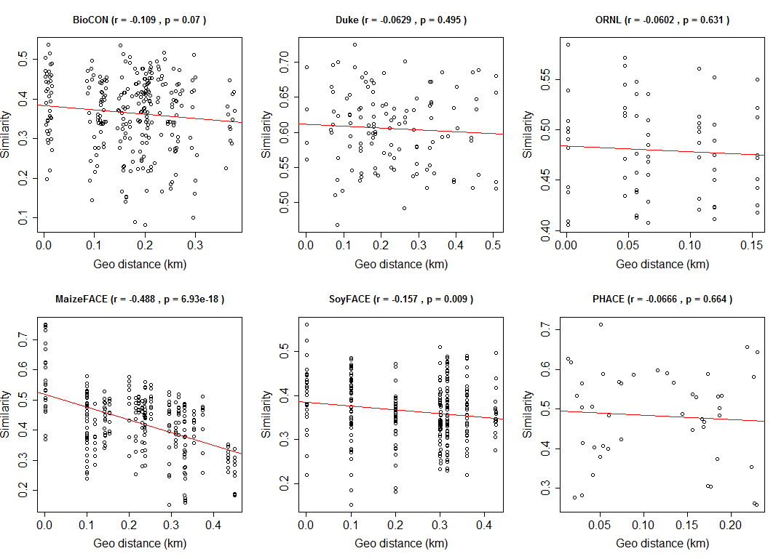

Figure S2 The distance decay rates of soil microbial communities within individual sites. Those rates were highly variable from significant distance relationships (MaizeFACE and SoyFACE), to no significant changes (BioCON, Duke, ORNL and PHACE). This may be largely due to the small distance scale, a limited number of plots for each site, and intertwining of multiple processes.

- Supplemental References

